**Infosys Foundation program (Module 5 project)**

PS.Vivek Raja(16bcs082)

VK.Visanth(16bcs081)

J.Manickaraj(16bcs074)

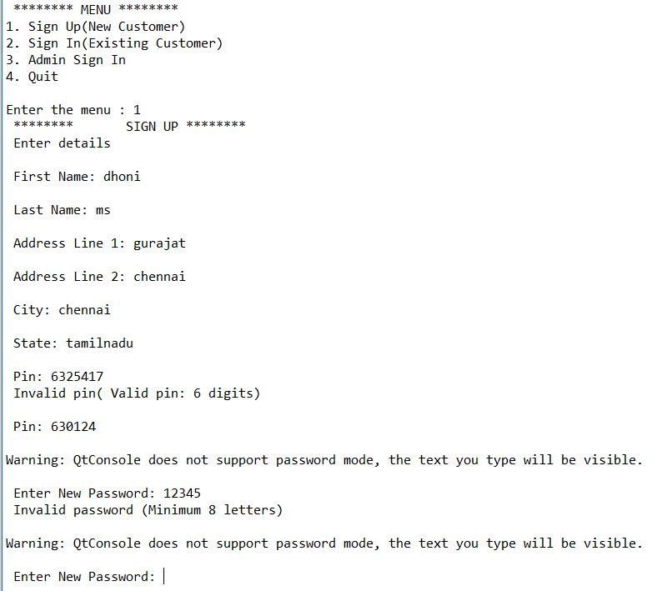

1. Signup

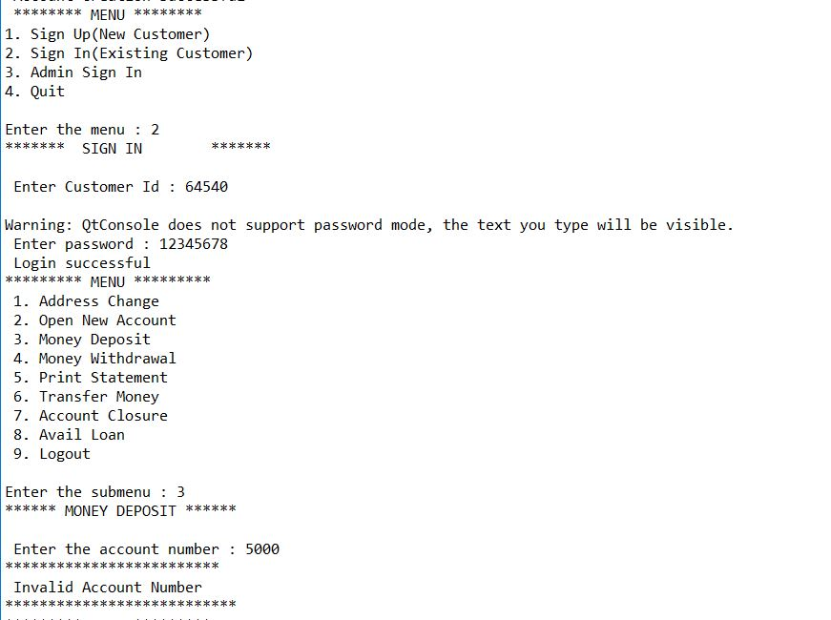

1. sign in

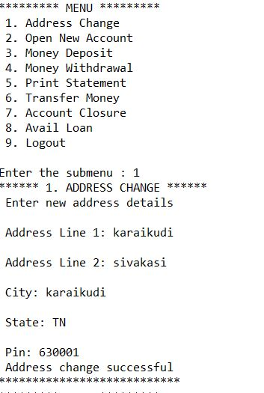

* 1. Address change

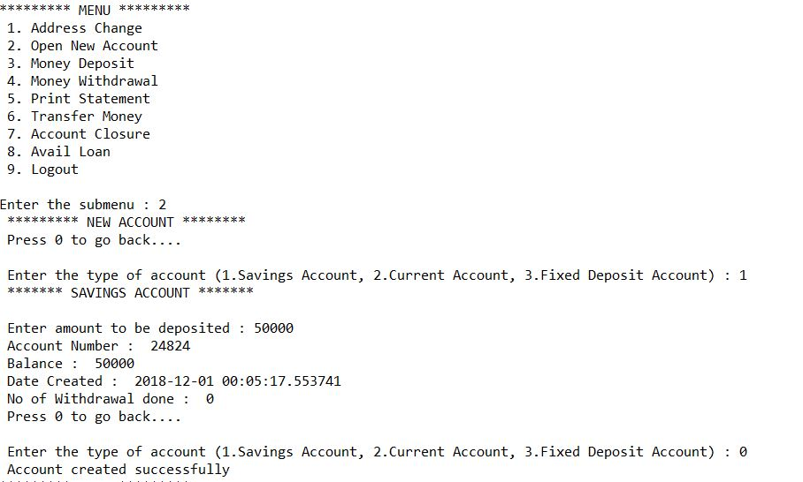

2.2 New account creation



2.3 Money deposit

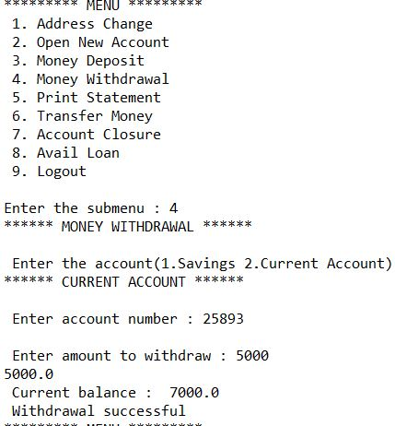

2.4 Money Withdraw

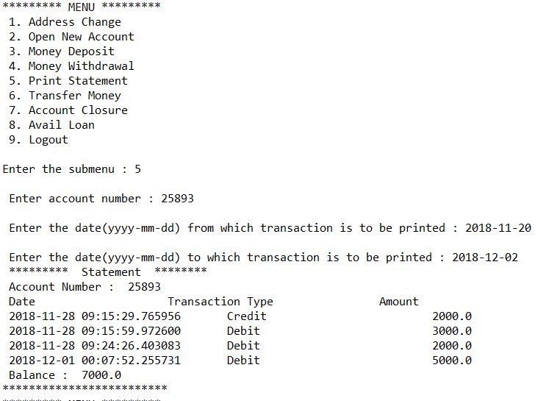

2.5 Statement of particular account

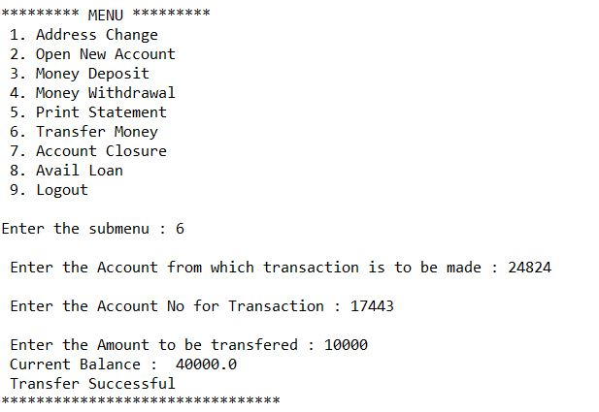

2.6 Money Transfer

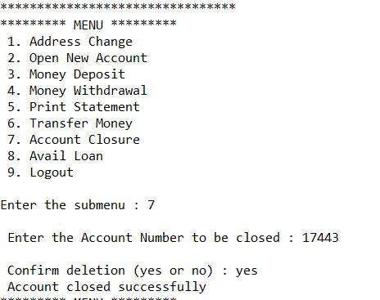

2.7 Account Closure

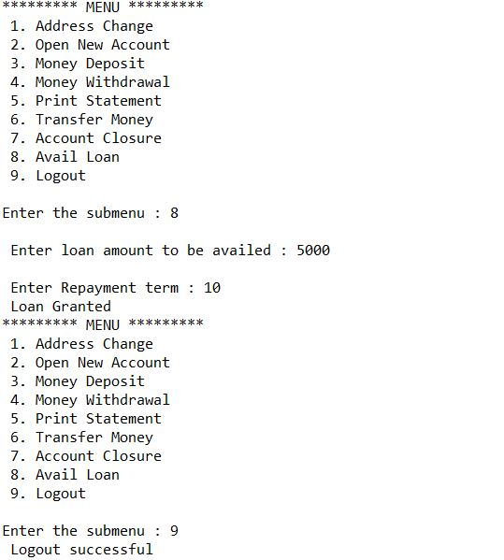

2.8 Avail loan And Logout

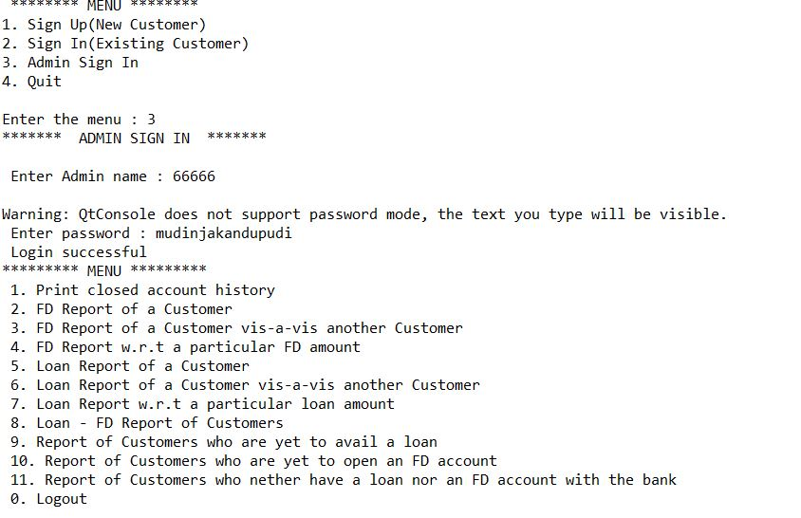

3.0 Admin Login

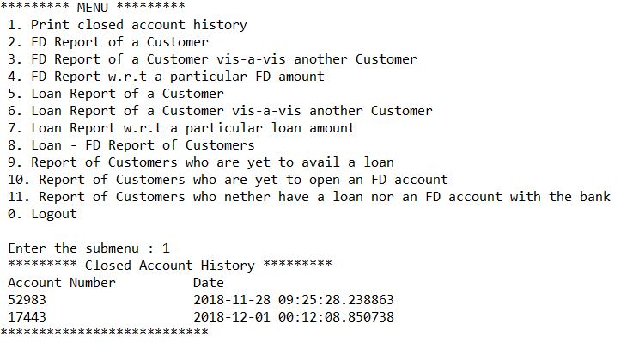

3.1 Closed Account History

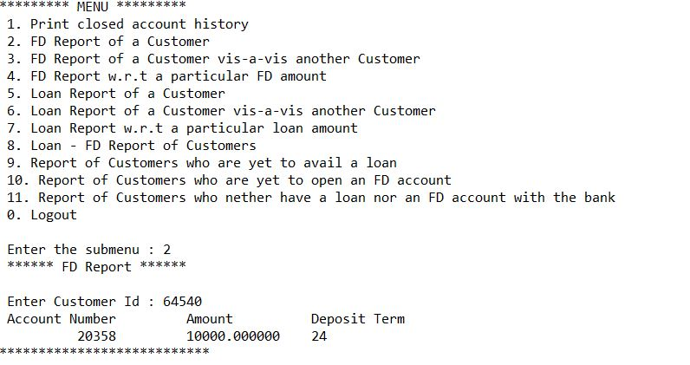

3.2 FD report of customer

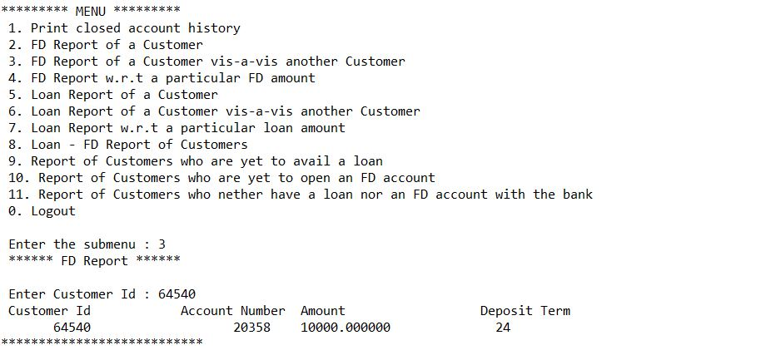

3.3 FD report of a customer vis-a-vis another Customer

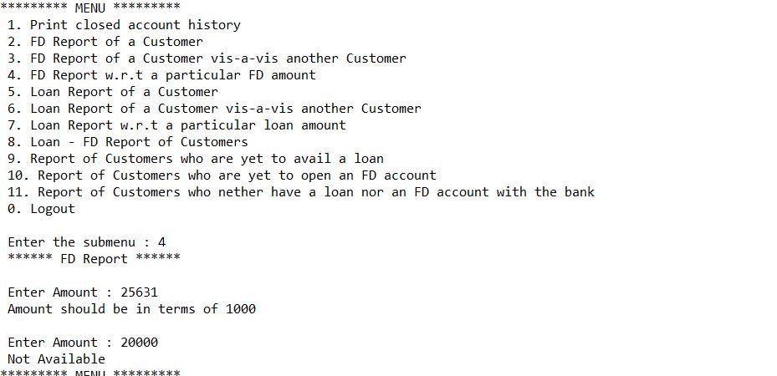

3.4 FD Report w.r.t a particular FD amount

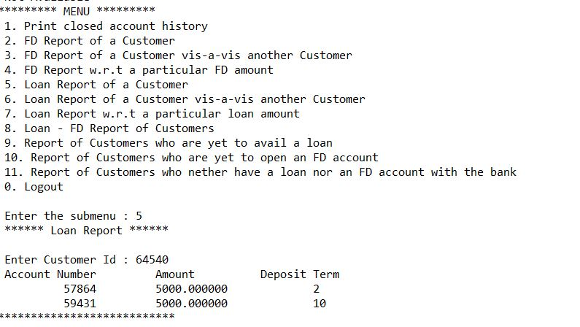

3.5 Loan report of a customer

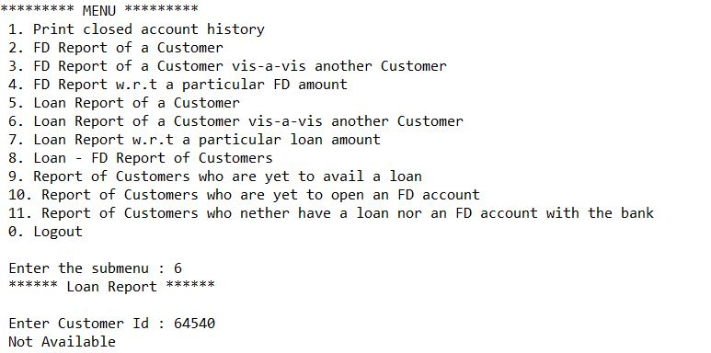

3.6 Loan Report of a Customer vis-a vis another Customer

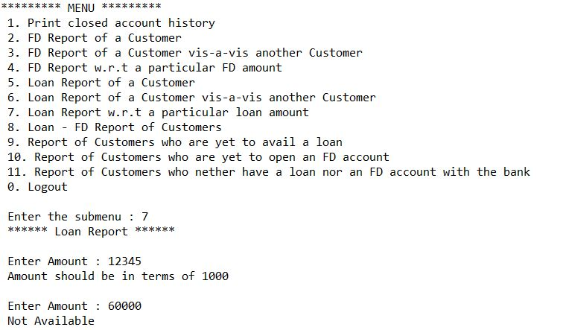

3.7 Loan Report w.r.t a particular loan amount

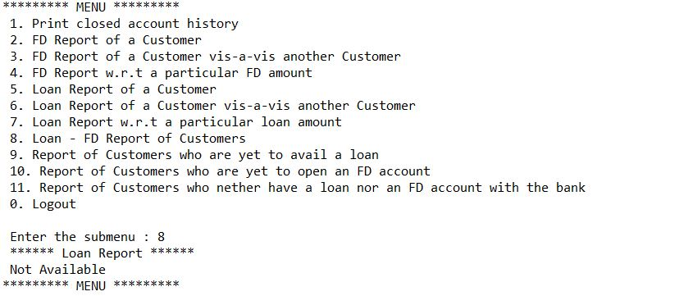

3.8 Loan – FD Report of Customer

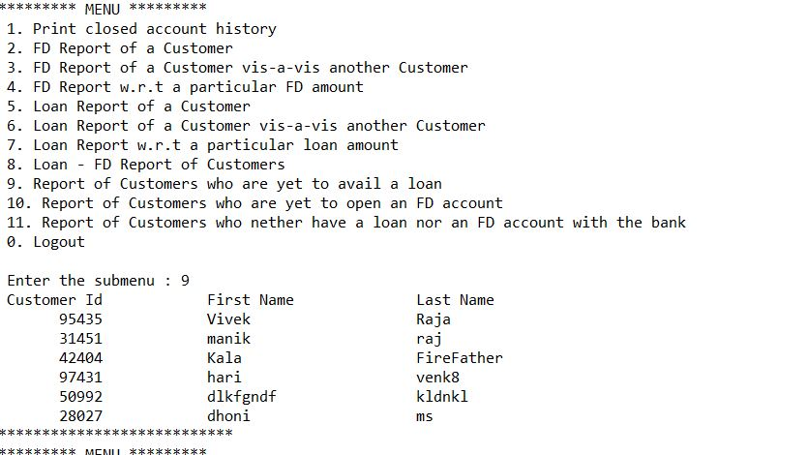

3.9 Report of Customer Who is yet to avail a Loan

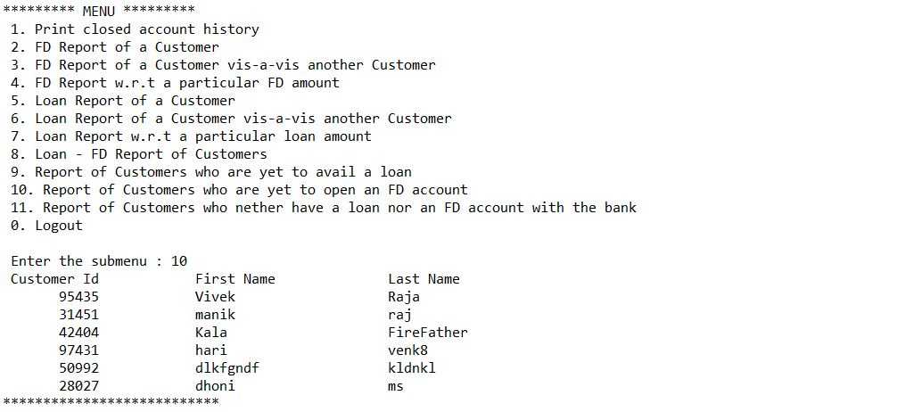

3.10 Report of Customer who is yet to open an FD account

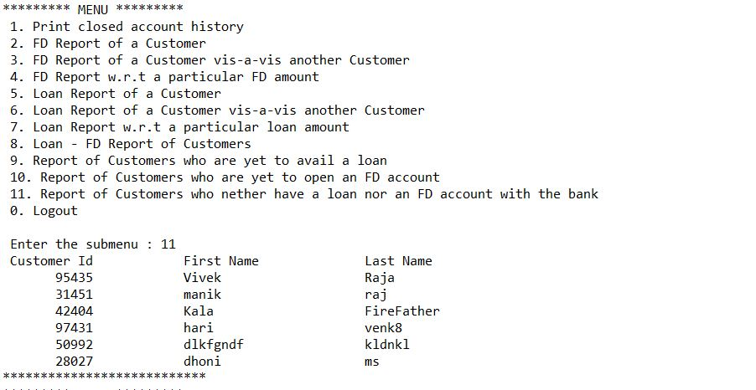

3.11 Report of Customer who are nether have a loan nor an FD account with the Bank